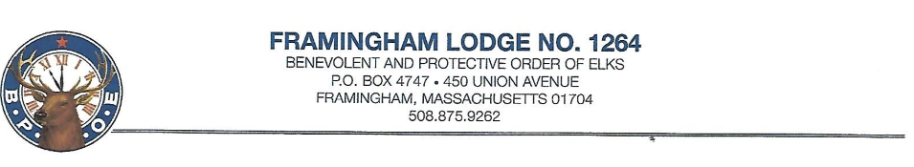
May Newsletter
Dear Framingham Lodge #1264 Members:
In lieu of a monthly bulletin, we are sending out a newsletter to update our members on what is happening at our lodge and to check in. I hope this letter finds you all well. Please stay safe and stay healthy.
We are living in a time that has turned our normal way of life into a secluded and isolated existence. I am hopeful that we will return to normalcy soon and get back to doing what the Elks is so good at doing.
The lodge has been closed since mid-March, but our dedicated bar manager, staff and volunteers have been working hard to clean, paint and make updates to our lodge. Many thanks and appreciation to all.
So what has been happening:
The Installation of Officers was scheduled for 4/4/20 but due to COVID 19 that was canceled. Instead, on 4/1/20, on a meeting night, Suzanne Brown PER installed the incoming officers of Framingham Lodge, many thanks to Sue.
Here is a list of your newly installed officers:
Donna Acorn : Exalted Ruler, Laura Medrano : Leading Knight, Janet Whitley : Loyal Knight, Chris Wozny : Lecturing Knight, Treasurer : Scott Penrod, Secretary : Jerry Blanchette, Board of Directors : BJ Ottaviani , Chaplain: Gerry Stevens,, Esquire: Dan O’Rourke
Committee Members:
BOD: Sue Brown-chairman, Ernie Moreau, Bob McCarthy, Brian Parker & BJ Ottaviani
Home Committee: Bob McCarthy-chairman, Brian Parker, Ernie Moreau, Jimmy Green, Chris Wozny, Patty Higgins and BJ Ottaviani
We are holding our regularly scheduled lodge meetings on the 1st and 3rd Wednesday of the month at 7 pm. We are doing our meetings via Zoom and it has worked out great. I want to assure you that the lodge is still operating even though our doors remain closed. All Framingham Elks are welcome to attend these meetings, all that is required is a computer, tablet of smart phone. Contact our secretary Jerry Blanchette if you’d like to attend and he will send you the meeting ID and password. jerryblanch@verizon.net or 508-383-5787
Last meeting I counted 16 people in attendance.
All functions have been cancelled until further notice: these include
The Bourne Bus Trip and Memorial Day events , Flag Day events , The Elks State & National Conventions
In closing, I want to take the opportunity to thank Bill Osborne for serving as our Exalted Ruler for the year 2019-2020, job well done. Thank you to the incoming officers and Committee Members who have volunteered to continue to keep Framingham #1264 the successful lodge it is.
Fraternally yours, Donna Acorn, ER(PER)
Secretary’s Corner: Communication during these times have brought us into new Media forms, and Snail Mail just isn’t the fastest way. Learning from this and preparing to live in the “New Norm”, please make sure the Lodge has your current email address and you know our Home Page on the Internet.
Please send a note to Secretary@framinghamelks.com and let me know your Name and Email Address.
Our Website Address is www.framinghamelks.com - Check for updates and ongoing Events. We also Post the Monthly Newsletters on the Site.
Thank you, stay safe. Jerry Blanchette PER, PDD, HLM

